Support Vector Machines (SVMs)

Task 1:

Q1: What is the margin and support vectors?

Margin is the width a linear classifier could be increased before hitting any data points, and a support vector is a datapoint that the margin hits. (As defined in the powerpoints)

Q2: How does SVM deal with non-separable data?

An SVM deals with non-separable data by using a soft margin that allows for some misclassification error, or mapping the features to a higher dimensional space where they are separable by some hyperplane. You can also use a kernel to make the data linearly separable.

Q3: What is a kernel?

A kernel function calculates an inner product of the input features in order to make the data linearly separable.

Q4: How does a kernel relate to feature vectors?

The kernel applies an inner product to the feature vectors using some function such as a polynomial, gaussian, sigmoid, etc…

(I got these answers using the 5.3SVM2 powerpoint)

Task 2: Construct a support vector machine that computes the kernel function. Use four values of +1 and -1 for both inputs and outputs:

* **[−1, −1] (negative)**
* **[−1, +1] (positive)**
* **[+1, −1] (positive)**
* **[+1, +1] (negative).**

Map the input [x1, x2] into a space consisting of x1 and x1x2. Draw the four input points in this space, and the maximal margin separator. What is the margin?

* 1: X1 = -1, X2 = -1 -> X1 = -1, X1X2 = +1
* 2: X1 = -1, X2 = +1 -> X1 = -1, X1X2 = -1
* 3: X1 = +1, X2 = -1 -> X1 = +1, X1X2 = -1
* 4: X1 = +1, X2 = +1 -> X1 = +1, X1X2 = +1

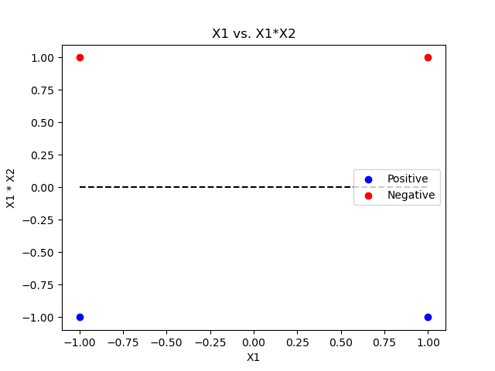

* Margin = 1

Task 3: Recall that the equation of the circle in the 2-dimensional plane is (x1 − a)2 + (x2 − b)2 − r2 = 0. Please expand out the formula and show that every circular region is linearly separable from the rest of the plane in the feature space (x1, x2, x12, x22).

* (x1 – a)2 + (x2-b)2 – r2 = 0
* X12 – 2a*x1 + a2 + x22 – 2b*x2 + b2 = 0
* X1 = (X12 + a2 + x22 – 2a*x2 + b2) / 2a
* X2 = (X12 + a2 + x22 – 2a*x1 + b2) / 2b
* X12 = 2a*x1 - a2 - x22 + 2a*x2 - b2
* X22 = 2a*x1 - a2 – x12 + 2a*x2 - b2
* X1, X2, X12, and X22 are all linearly separable from the rest of the features

Task 4: Recall that the equation of an ellipse in the 2-dimensional plane is c(x1 − a)2 + d(x2 − b)2 − 1 =

Please show that an SVM using the polynomial kernel of degree 2, K(u, v) = (1 + u · v)2, is equivalent to a linear SVM in the feature space (1, x1, x2, x12, *x22*, x1x2) and hence that SVMs with this kernel can separate any elliptic region from the rest of the plane.

Used powerpoints and “The Kernel Trick in Support Vector Classification” as a reference.



Task 5: Consider the following training data

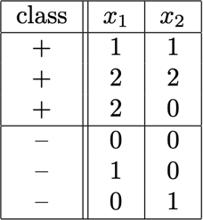

1. **Plot these six training points. Are the classes {+, −} linearly separable?**

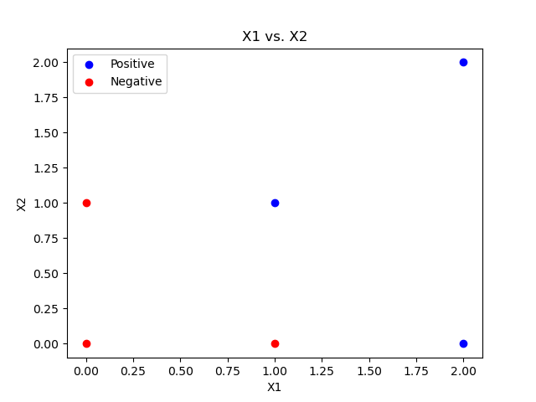

From the above plot , it is clear that the classes are linearly separable, (by a line with negative slope and y-intercept ~= 1.5)

**b) Construct the weight vector of the maximum margin hyperplane by inspection and identify the support vectors.**





**Support vectors are those data points that define the hard margin. In this case there are 4:**

**S1 = {0, 1} (-), S2 = {1, 0} (-), S3 = {1, 1} (+), S4 = {2, 0}.**

**There is also a margin of 1/(sqrt(2)) in this case.**

Task 6: Consider a dataset with 3 points in 1-D:

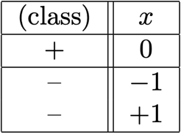

1. **Are the classes {+, −} linearly separable?**

**The classes are not linearly separable, as the + class is between two points in the – class on the x-axis**

1. **Consider mapping each point to 3-D using new feature vectors φ(x) = [1, sqrt(2)x, x^2 ] . Are the classes now linearly separable? If so, find a separating hyperplane.**

**See next page for work…**



Task 7: Learning SVMs on the Titanic dataset. Please report your five-fold cross validation classification accuracies on Titanic training set, with respect to the linear, quadratic, and RBF kernels. Which kernel is the best in your cases?

**Linear Kernel Accuracy (5-fold): 0.671156**

**Quadratic Kernel Accuracy (5-fold): 0.672278**

**RBF Kernel Accuracy (5-fold): 0.705948**

**In this case, the RBF kernel performed the best (~70% accuracy)**

**See code for reference.**

**GITHUB LINK:**

**https://github.com/malleyconnor/cap5610/tree/master/hw4**